C++ Research READ and WRITE to FILES in C++

<http://www.cplusplus.com/doc/tutorial/files/> - read, write to files, read file line by line

<https://www.w3schools.com/cpp/cpp_files.asp> read and write to files, read files line by line using while loop etc.

#include fsteam – used to create, write and write to files.

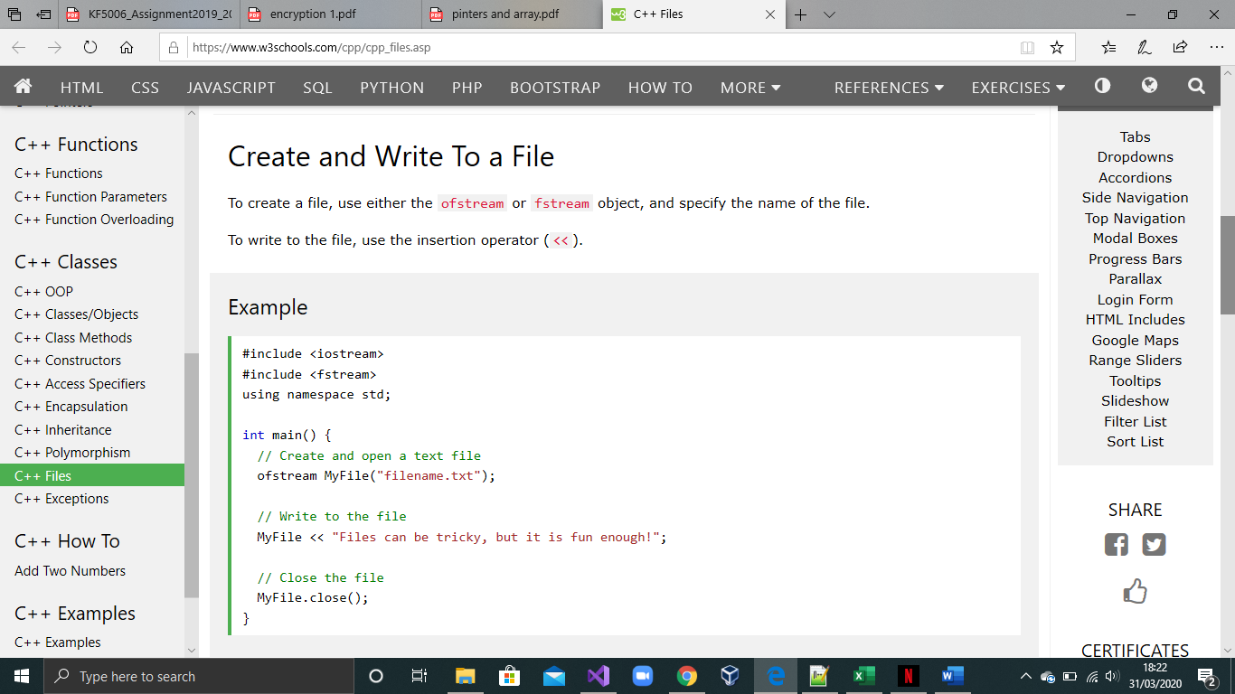Create ans Wite to a file

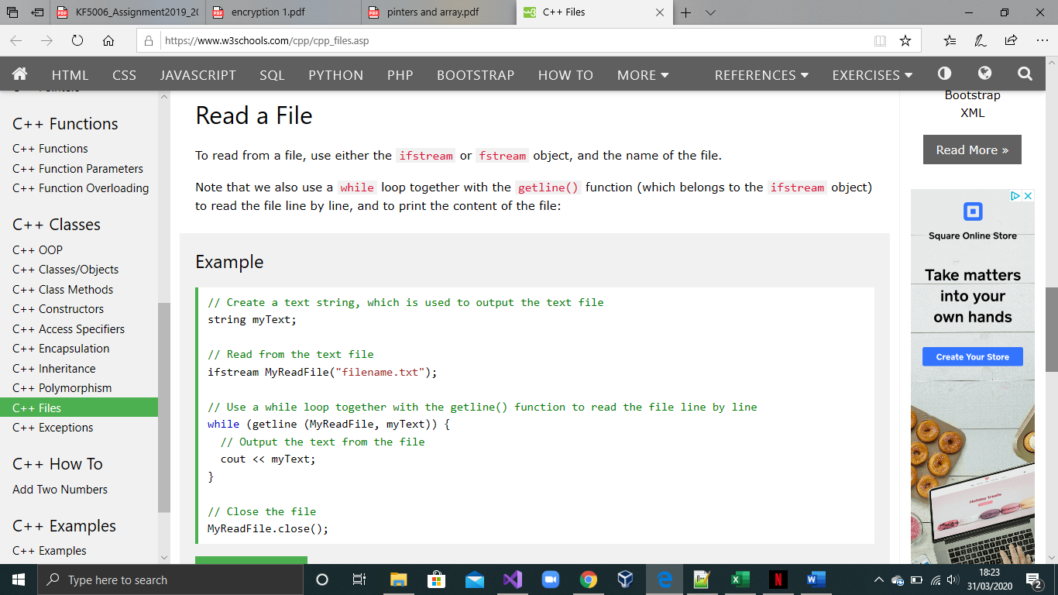

Read a File

Turn struct into class: <https://stackoverflow.com/questions/8470972/c-change-from-struct-to-classes>

Struct printype

{

};

Will be turned to:

Class printype

{

Public:

};

Functions will have something similar:

Void dpinfo(printype) ,

Becomes

Class printype

{

Void dpinfo

};